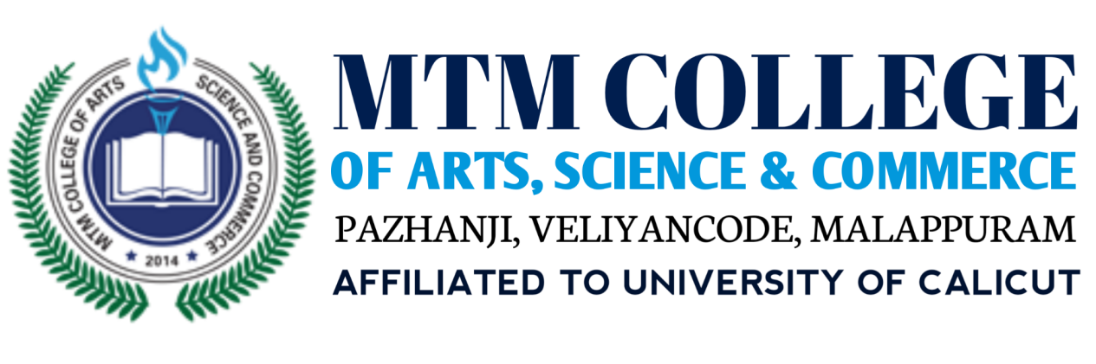

**NATURE CLUB PROGRAMME REPORT**

ACADEMIC YEAR:2021-2022

DATE : 01/12/2021

NAME OF THE EVENT:" POSTER MAKING COMPETITION "

|  |  |
| --- | --- |
| DATE AND TIME | 27/07/2021,WEDNESDAY |
| EVENT VENUE | N9 |
| ORGANIZED BY | NATURE CLUB |
| TARGETED AUDIENCE | STUDENTS OF MTMCOLLEGE |

**Objectives**

**•To encourage the students to improve their art skill.**

**•To create an awareness among students about world nature consrevation day.**

**Details of the event**

MTM College Nature Club in association with IQAC conducted a poster making competition in connection with observation of World National Conservation day.The programme aimed to make awareness on the World Nature Conservation and improve the art skill of the students. The competition was open to all the students from different departments.Totally 21 students participated in the programme.Participants enthusiastically participated in the event and made beautiful and creative posters.The programme was Coordinated by Nivya Manoharan (Asst Prof. of Commerce Department).Mr.Faisa Bava welcomed all to the Programme and Ms Rahyanath(Department of management) ,Ms Nimisha (Department of management) also helped to conduct a programme succsessfully.Vote of Thanks was Delivered by Mr.Anas ( student coordinator of nature club ,English Department).The programme was successful and the objectives of the Programme were achieved as it helped the students to understand the Significance of the conservation of Nature.

The winners of the event :

First Position :Vishnuraj . C (S3 Bcom cooperation )

Second Position :Anfad K M (S3 B Com Computer application)

Third Position :Salman Faris K V (S3 BBA)

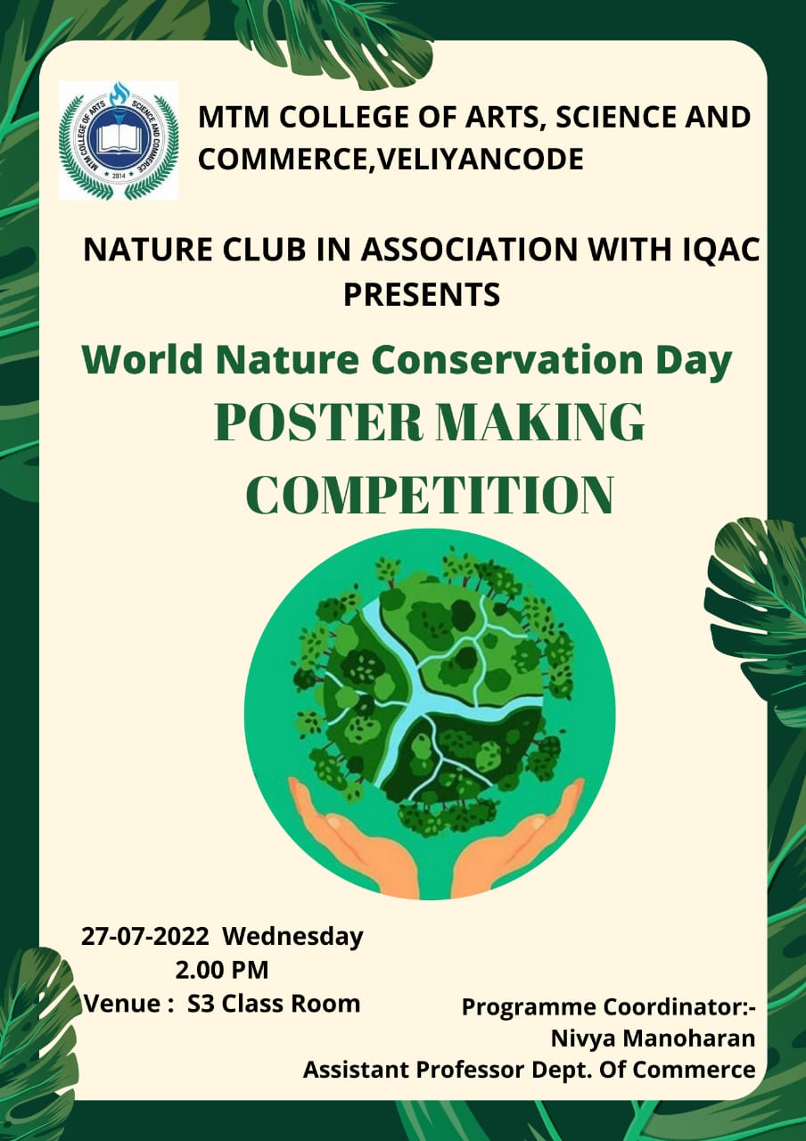

Photos: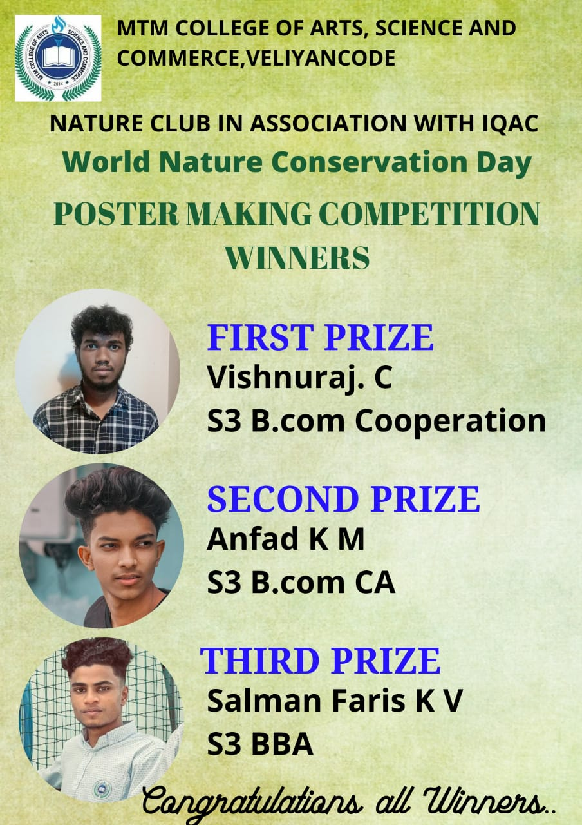First: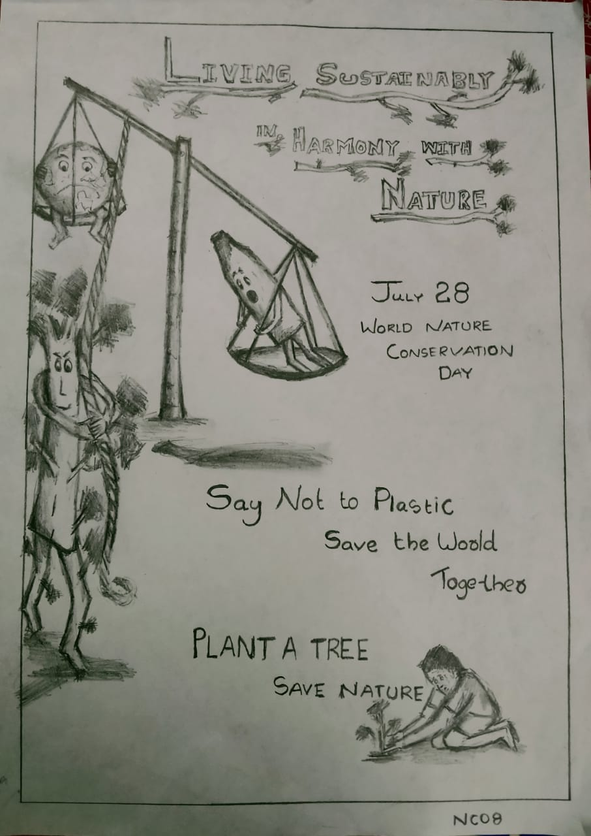

Second: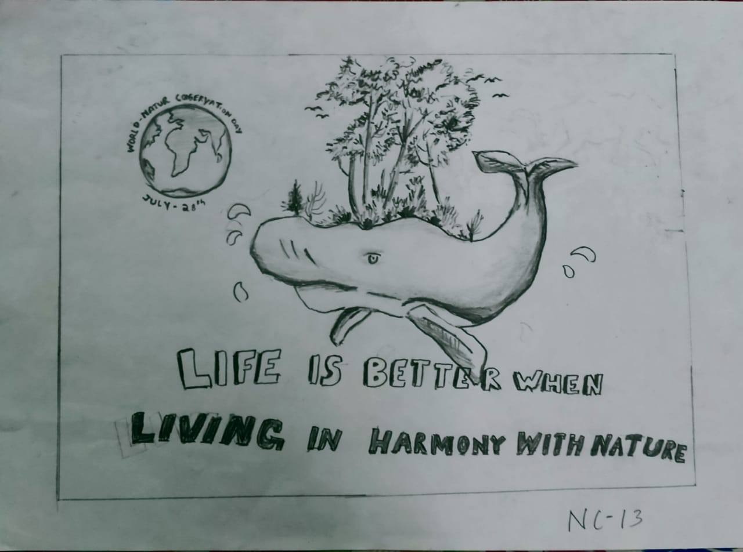

Third :

